# Creating Your First 2D NumPy Array in Python

Below is the image showing the exercise from DataCamp:

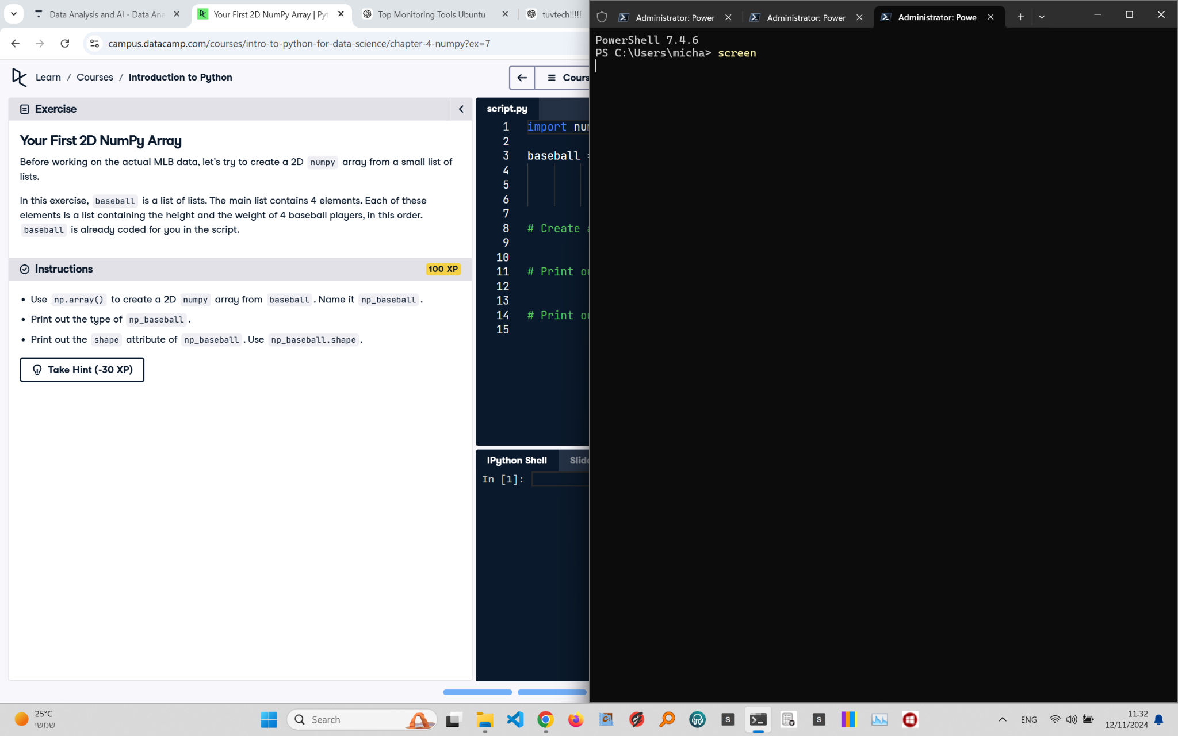

Exercise Explanation:

The exercise requires creating a 2D NumPy array from a list of lists called 'baseball'. You then need to print the type of the array and the shape attribute to verify the 2D structure.

Answer Code:

import numpy as np  
np_baseball = np.array(baseball)  
print(type(np_baseball))  
print(np_baseball.shape)

Explanation of the Code:

We use np.array() to convert 'baseball' into a 2D NumPy array named np_baseball. Using type(np_baseball), we confirm it's a NumPy array, and np_baseball.shape returns the dimensions of the array, which shows the number of rows and columns, verifying its 2D structure.